PROJECT REPORT
Pro To-Do List
A Feature-Rich Task Management Web Application

Name | Michael Maged
ID | 22P0005
GitHub Repository | https://github.com/Michael-Maged/IP-Labs

1. Project Overview
Pro To-Do List is a lightweight, browser-based task management application built entirely with vanilla web technologies — HTML5, CSS3, and JavaScript. It requires no external libraries or build tools, making it instantly deployable in any web browser.
The application allows users to manage daily tasks efficiently through a clean, intuitive interface. It focuses on core productivity features including task creation, completion tracking, and flexible sorting and filtering options, all stored locally in the browser.

2. Features & Functionality
The table below summarises each feature exposed through the UI:

Feature | Description
Add Task | Type a task name in the input field and click the ➕ button to add it to the list.
Complete Task | Click the checkbox next to any task to toggle its completion status.
Delete Task | Remove individual tasks permanently from the list.
Filter — All | Show all tasks regardless of completion status.
Filter — Completed | Display only tasks that have been marked as done.
Filter — Incomplete | Display only tasks that are still pending.
Sort A–Z | Alphabetically sort the visible task list in ascending order.
Sort by Time | Restore the original insertion order of tasks.

3. Project Structure
The project follows a minimal three-file architecture:

File | Purpose
index.html | HTML structure, input field, filter/sort buttons, task list container.
style.css | Visual design — layout, colours, hover states, and responsive styling.
script.js | All application logic — task CRUD, filtering, sorting, and localStorage persistence.

4. Application Screenshots
The screenshots below illustrate the main views and interactions within the application.

Main Interface
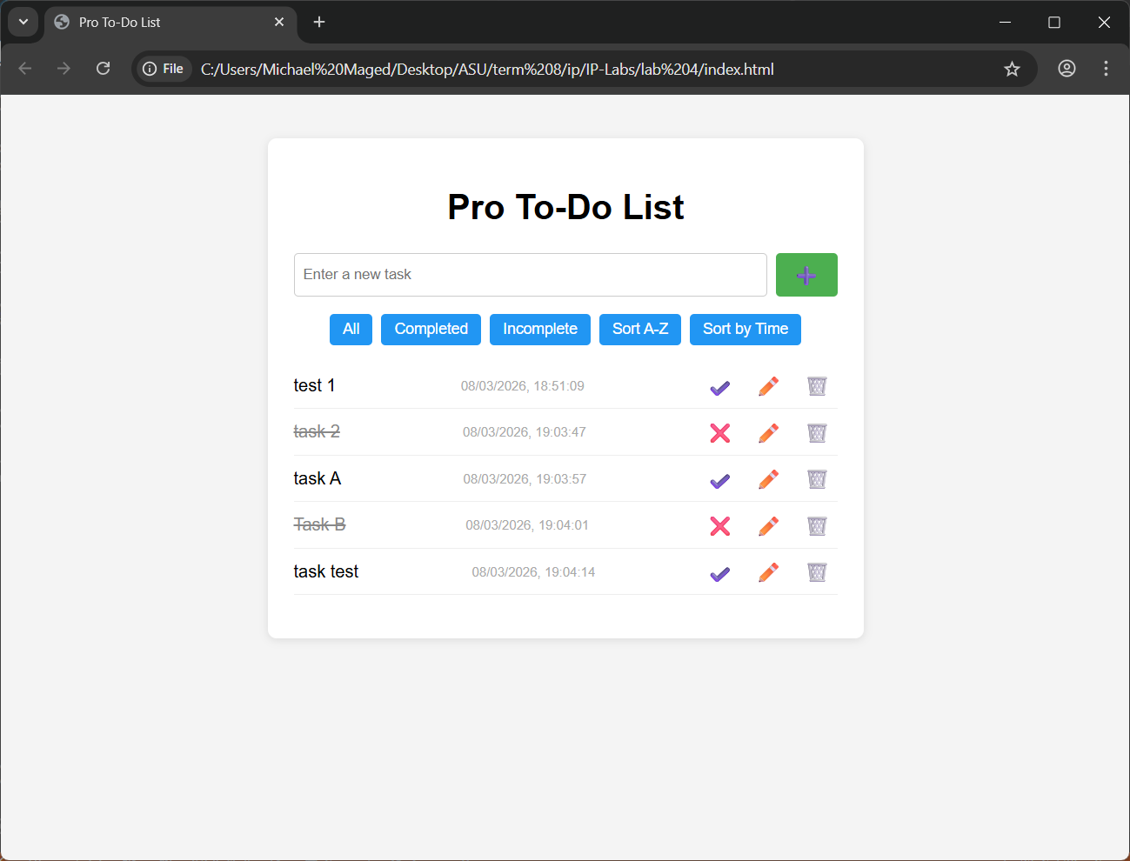

Sorted Task List
